Exp:1
#include<stdio.h>
#include<ctype.h>
#include<string.h>
int main()
{
int i,ic=0,m,cc=0,oc=0,j;
char b[30],operators[30],identifiers[30],constants[30];
printf("enter the string : ");
scanf("%[^\n]s",&b);
for(i=0;i<strlen(b);i++)
{
if(isspace(b[i]))
{
continue;
}
else if(isalpha(b[i]))
{
identifiers[ic] =b[i];
ic++;
}
else if(isdigit(b[i]))
{
m=(b[i]-'0');
i=i+1;
while(isdigit(b[i]))
{
m=m*10 + (b[i]-'0');
i++;
}
i=i-1;
constants[cc]=m;
cc++;
}
else
{
if(b[i]=='*')
{
operators[oc]='*';
oc++;
}
else if(b[i]=='-')
{
operators[oc]='-';
oc++;
}
else if(b[i]=='+')
{
operators[oc]='+';
oc++;
}
else if(b[i]=='=')
{
operators[oc]='=';
oc++;
}
}
}
printf(" identifiers : ");
for(j=0;j<ic;j++)
{
printf("%c ",identifiers[j]);
}
printf("\n constants : ");
for(j=0;j<cc;j++)
{
printf("%d ",constants[j]);
}
printf("\n operators : ");
for(j=0;j<oc;j++)
{
}
printf("%c ",operators[j]);
}
Output:
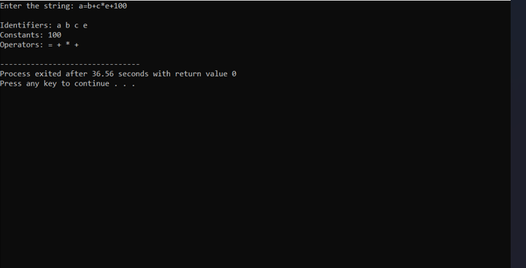

Exp:2
#include<stdio.h>
#include<conio.h>
int main()
{
char com[30];
int i=2,a=0;
printf("\n Enter comment:");
gets(com);
if(com[0]=='/')
{
if(com[1]=='/')
printf("\n It is a comment");
else if(com[1]=='*')
{
for(i=2;i<=30;i++)
{
if(com[i]=='*'&&com[i+1]=='/')
{
printf("\n It is a comment");
a=1;
break;
}
else
continue;
}
if(a==0)
printf("\n It is not a comment");
}
else
printf("\n It is not a comment");
}
else
printf("\n It is not a comment");
}
Output:
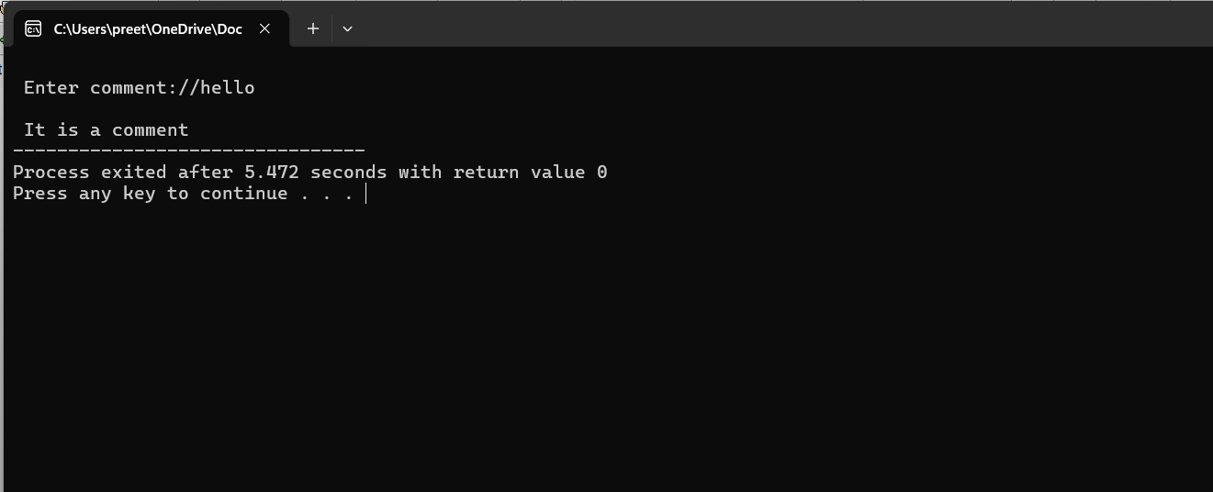

Exp:3
#include<stdio.h>
#include<stdlib.h>
#include<string.h>
#include<ctype.h>
int isKeyword(char buffer[]){
char keywords[32][10] =
{"main","auto","break","case","char","const","continue","default",
"do","double","else","enum","extern","float","for","goto",
"if","int","long","register","return","short","signed",
"sizeof","static","struct","switch","typedef",
"unsigned","void","printf","while"};
int i, flag = 0;
for(i = 0; i < 32; ++i)
{
if(strcmp(keywords[i], buffer) == 0)
{
flag = 1;
break;
}
}
return flag;
}
int main()
{
char ch, buffer[15], operators[] = "+-*/%=";
FILE *fp;
int i,j=0;
fp = fopen("flex_input.txt","r");
if(fp == NULL){
printf("error while opening the file\n");
exit(0);
}
while((ch = fgetc(fp)) != EOF){
for(i = 0; i < 6; ++i){
if(ch == operators[i])
printf("%c is operator\n", ch);
}
if(isalnum(ch)){
buffer[j++] = ch;
}
else if((ch == ' ' || ch == '\n') && (j != 0)){
buffer[j] = '\0';
j = 0;
if(isKeyword(buffer) == 1)
printf("%s is keyword\n", buffer);
else
printf("%s is identifier\n", buffer);
}
}
fclose(fp);
return 0;
}
Output:

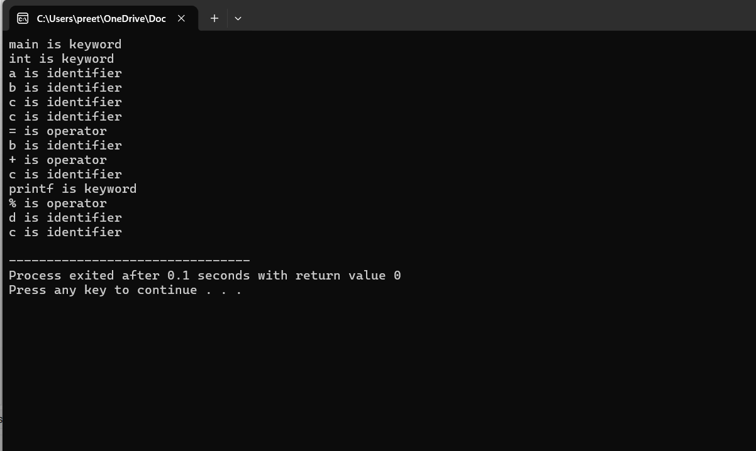
Exp:4
#include<stdio.h>
#include<conio.h>
int main()
{
char s[5];
printf("\n Enter any operator:");
gets(s);
switch(s[0])
{
case'>':
if(s[1]=='=')
printf("\n Greater than or equal");
else
printf("\n Greater than");
break;
case'<':
if(s[1]=='=')
printf("\n Less than or equal");
else
printf("\nLess than");
break;
case'=':
if(s[1]=='=')
printf("\nEqual to");
else
printf("\nAssignment");
break;
case'!':
if(s[1]=='=')
printf("\nNot Equal");
else
printf("\n Bit Not");
break;
case'&':
if(s[1]=='&')
printf("\nLogical AND");
else
printf("\n Bitwise AND");
break;
case'|':
if(s[1]=='|')
printf("\nLogical OR");
else
printf("\nBitwise OR");
break;
case'+':
printf("\n Addition");
break;
case'-':
printf("\nSubstraction");
break;
case'*':
printf("\nMultiplication");
break;
case'/':
printf("\nDivision");
break;
case'%':
printf("Modulus");
break;
default:
printf("\n Not a operator");
}
}

Output:
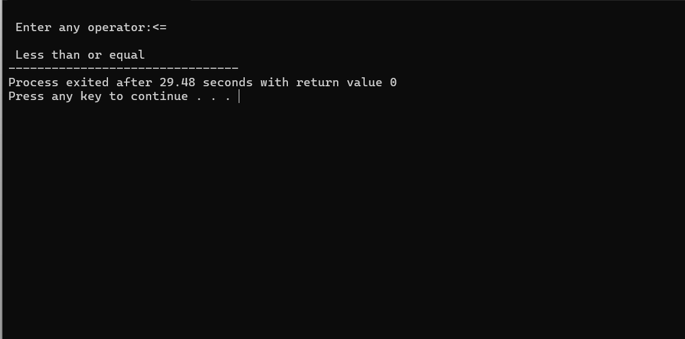

Exp:5
#include <stdio.h>
#include <ctype.h>

int main()
{
char str[100];
int words = 0, lines = 0, characters = 0;
int inWord = 0;

printf("Enter text (use ~ to end):\n");

scanf("%99[^~]", str);

for (int i = 0; str[i] != '\0'; i++)
{
characters++;

if (str[i] == '\n')
{
lines++;
}

if (str[i] == ' ' || str[i] == '\t' || str[i] == '\n')
{
inWord = 0;
}
else if (inWord == 0)
{
words++;
inWord = 1;
}
}

if (characters > 0 && lines == 0)
{
lines = 1;
}

printf("\nTotal number of words: %d\n", words);
printf("Total number of lines: %d\n", lines);
printf("Total number of characters: %d\n", characters);

return 0;
}

Output:
